**Frontend Development with React.js**

**Project Documentation format**

1. **Introduction**

**Project Title**: Cookbook: Your Virtual Kitchen Assistant

**Team Lead**: Rosy. B

**Team Members**:

* + - **Thulasi**. K
    - **Prema. K**
    - **Roja. R**

1. **Project Overview**

**Purpose**:

The *CookBook* project serves as a virtual kitchen assistant, helping users efficiently discover and manage recipes. It allows users to browse a wide range of recipes, save favorites, and follow step-by-step instructions. The main objective is to simplify meal planning and promote home cooking with an intuitive and interactive interface.

**Features**:

Recipe Discovery: Explore a wide variety of recipes categorized by type, ingredients, and user preferences.

Search and Filter*:* Quickly find specific recipes with advanced search and filtering options.

Step-by-Step Instructions*:* Follow clear and concise guidance for preparing each recipe.

Favorites and Personalization*:* Save favorite recipes and receive tailored recommendations.

Ingredient Checker: Suggests recipes based on the ingredients users have on hand.

User Authentication: Secure login and registration to store user preferences and saved recipes.

Responsive Design*:* Optimized for seamless use on desktops, tablets, and smartphones.

1. **Architecture**

**Component Structure**:

The project adopts a modular, component-based design, dividing the UI into reusable elements. Key components include:

Navbar*:* Manages navigation and user authentication status.

RecipeCard*:* Showcases recipe summaries in an engaging layout.

RecipeDetails: Displays detailed information about selected recipes, including ingredients and steps.

SearchBar: Enables users to search and filter recipes efficiently.

FavoritesList*:* Highlights the user’s saved recipes.

**State Management**:

The application utilizes the Context API for managing global state, ensuring smooth data sharing across components. It efficiently handles user authentication, recipe preferences, and UI interactions.

**Routing**:

The project employs *React Router* for client-side navigation, providing seamless transitions between key pages:

Home Page*:* Showcases trending and recommended recipes.

Recipe Details Page*:* Displays comprehensive details about selected recipes.

Favorites Page*:* Lists recipes saved by the user.

Login/Signup Page*:* Facilitates user authentication and account creation.

1. **Setup Instructions**

**Prerequisites**: Ensure the following dependencies are installed:

* + - Node.js (v14 or later)
    - npm or yarn
    - React.js (latest stable version)
    - React Router.

**Installation**:

1. Clone the repository:

* + - sh
    - git clone https://github.com/yourrepo/cookbook.git

2. Navigate to the project directory:

* + - sh
    - cd cookbook

3. Install dependencies:

* + - sh
    - npm install

4. Run the application:

* + - sh
    - npm start

1. **Folder Structure**

**Client**:

**/src**: Main source folder for the application.

**/components**: Contains reusable React components.

**/pages**: Includes page-level components.

**/assets**: Stores images, icons, and other static files.

**/services**: Handles API calls and interactions with the backend.

**/context**: Manages context providers for global state management.

**Utilities**:

* + **Custom Hooks:** Simplify tasks like API requests, local storage handling, and managing user preferences.
  + **Helper Functions:** Provide utilities for data formatting, filtering, and validation.

1. **Running the Application**

Run the frontend server with:

sh

npm start

This will launch the application at http://localhost:3000/

1. **Component Documentation**

**Key Components**:

**RecipeCard:** Displays a brief summary of a recipe.

**RecipeDetails:** Offers detailed information about a selected recipe.

**FavoritesList:** Lists recipes saved by the user.

**SearchBar:** Allows users to filter recipes based on criteria.

**Reusable Components:**

**Button:** A customizable, styled button component.

**Modal:** Used for displaying popup dialogs.

**FormField:** Manages user inputs in forms.

1. **State Management**

**Global State:**

**User Authentication State: Handles user login status and session details.**

**Recipe Data State: Maintains fetched recipe information for seamless access.**

**Local State:**

**Search Input: Captures user input for recipe filtering.**

**Toggle States: Controls the visibility of modals and dropdown menus.**

1. **User Interface**

The UI highlights include:

**Homepage:** Displays trending recipes in an engaging layout.

**Recipe Details Page:** Offers step-by-step instructions for preparing selected recipes.

**Favorites Section:** Showcases the user’s saved recipes for quick access.  
*Screenshots and GIFs can be added to demonstrate these features.*

1. **Styling**

CSS Frameworks/Libraries:

Tailwind CSS for styling.

StyledComponents for scoped component styling.

Theming:

A light/dark mode toggle is implemented to enhance user experience.

1. **Testing**

**Testing Strategy**:

**Unit Testing:** Utilized *Jest* and *React Testing Library* to verify the functionality of individual components.

**Integration Testing:** Validated that interactions between components function as intended.

**End-to-End Testing:** Conducted full application testing using *Cypress* to ensure seamless user experience.

**Code Coverage**:

Coverage reports generated using Jest ensure comprehensive test validation.

1. Screenshots or Demo

Home Page: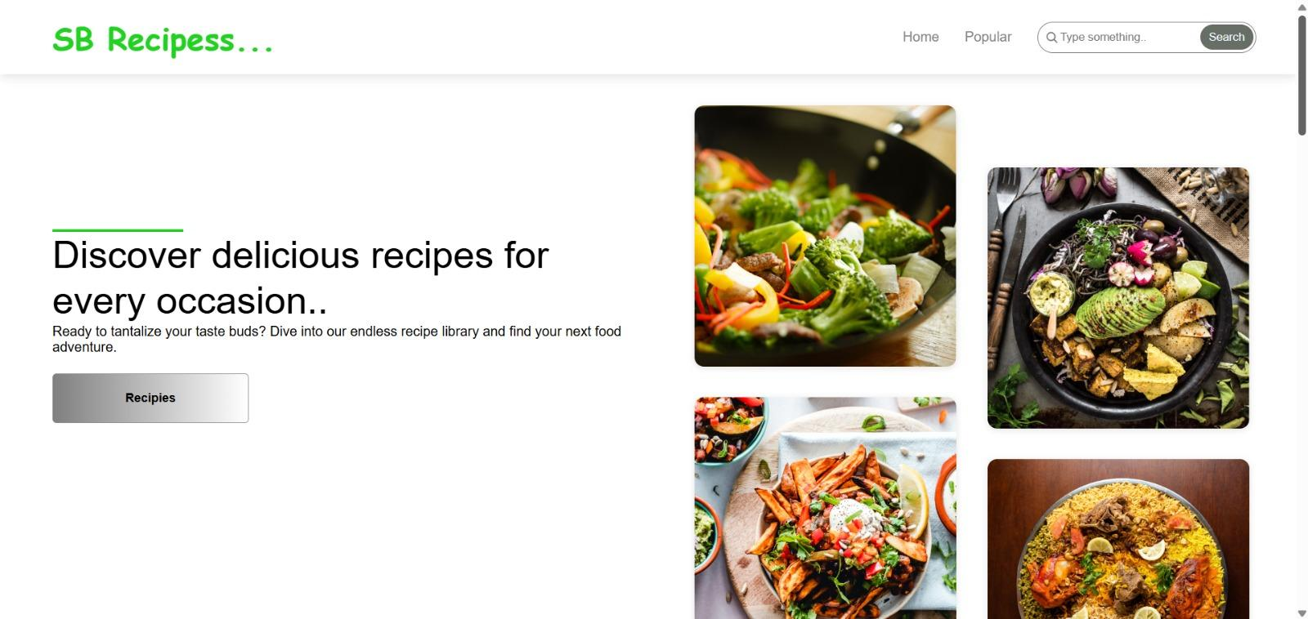

Step By Step Instructions:

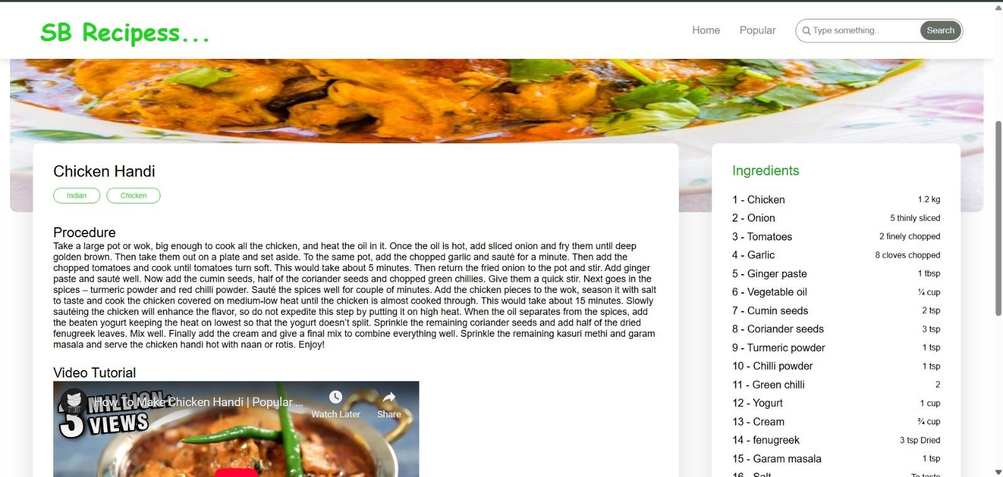

Popular Categories: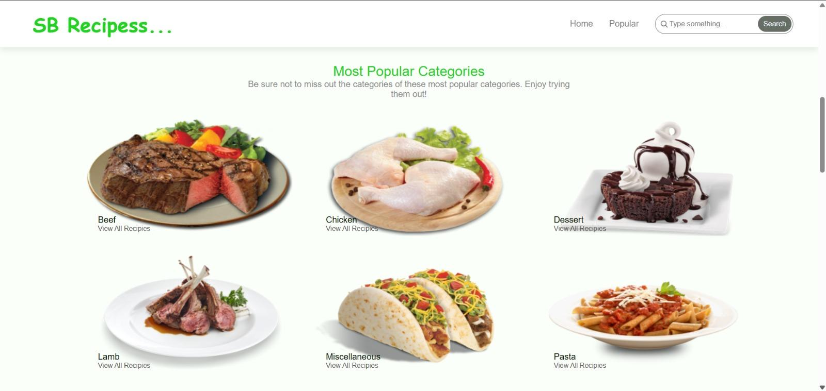

Categories:

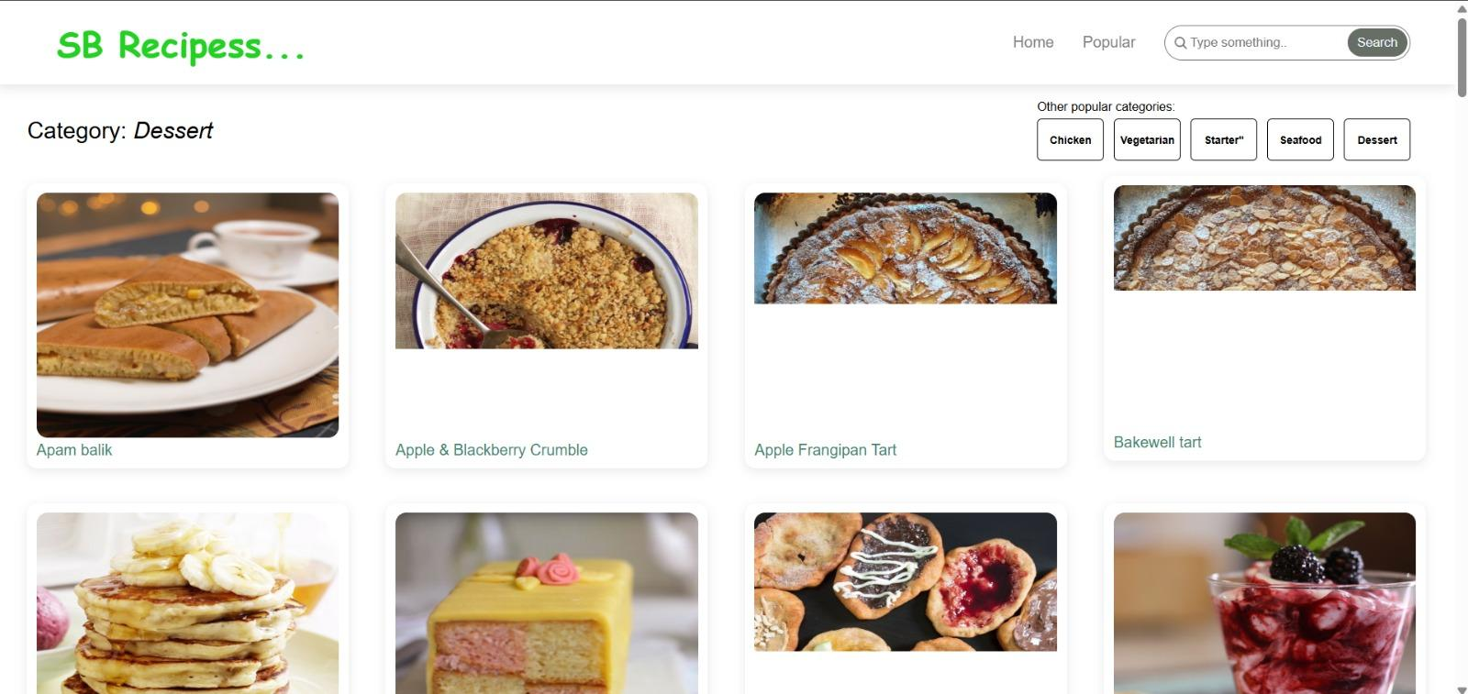

**13.Known Issues**

* **Delayed API Responses: Some API calls may take longer to load.**
* **Mobile UI Glitches: Minor design inconsistencies in certain mobile resolutions.**

**14. Future Enhancements**

* **AI-Powered Recipe Suggestions: Personalized recommendations tailored to user behavior and preferences.**
* **Community Recipes: Allow users to upload, share, and discover recipes contributed by the community.**
* **Voice-Guided Cooking: Provide step-by-step cooking instructions through voice assistance.**
* **Advanced Filtering: Add filters for dietary preferences like vegan, gluten-free, and more.**